**FORWARDERS EVALUATION MANUAL**

1. Go to <http://10.27.1.170:9494/default.aspx> and login your credential

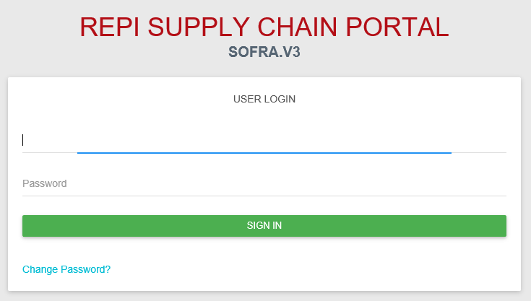

1. Select TERMINAL and look for Forwarders Evaluation

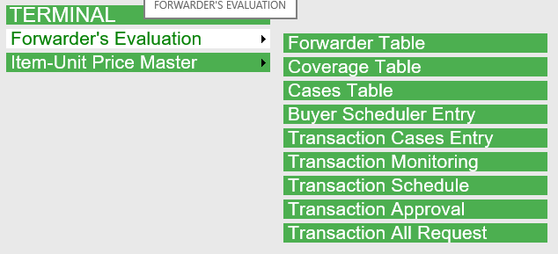

1. **How to use Forwarder Table**
   1. Go to TERMINAL > Forwarders Evaluation > Forwarder Table

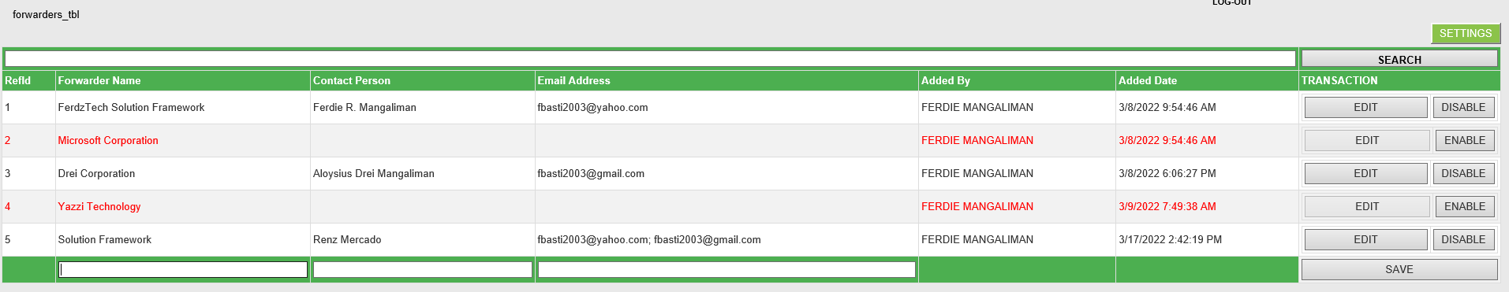

* 1. In the right side you will see SETTINGS button, this setting allows you to show/hide fields available in the list then hit SAVE CHANGES button to set your personal settings.

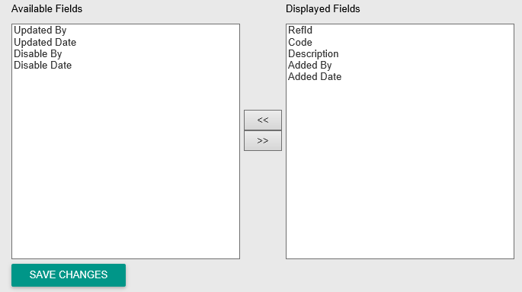

* 1. To add new forwarder, enter forwarder name, contact person and email address in the textboxes below click the save button highlighted in red.

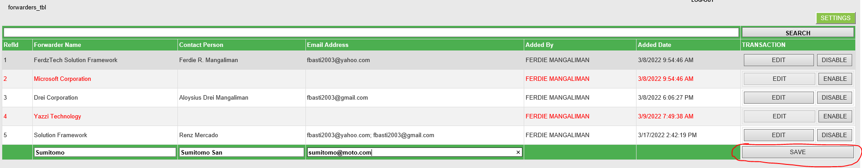

* 1. Confirmation will pop up after successfully saved.

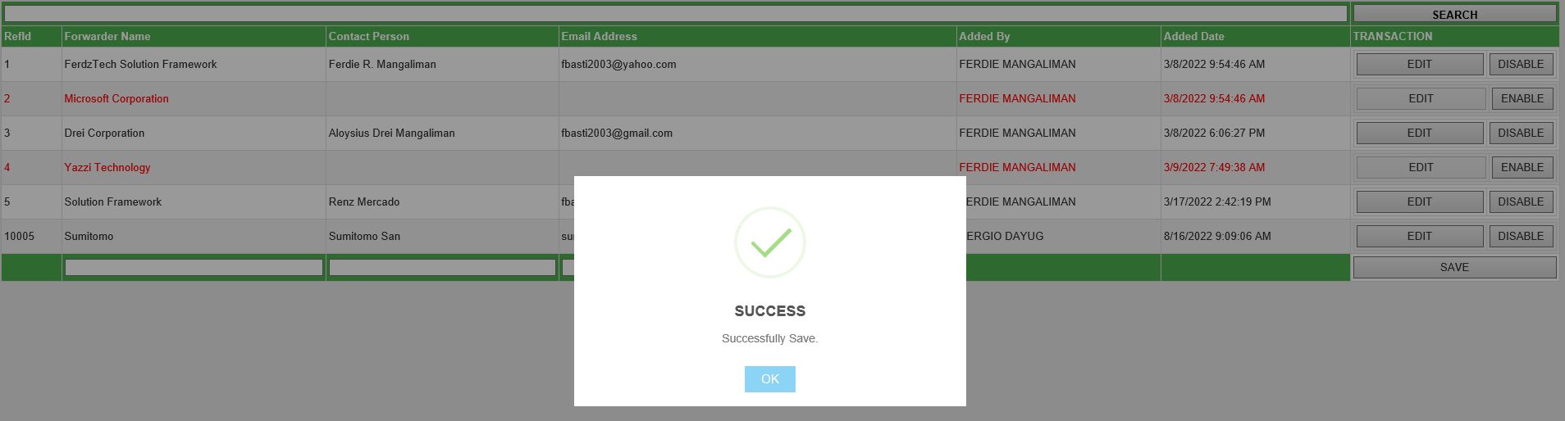

* 1. To edit the record, just click the edit button in the right side and the data will be ready for updates and click the save button in line with it to save changes. Popup confirmation with display.
  2. To disable record, just click the disable button in the right side and the data will automatically disable after hitting the button. Popup confirmation with display.

1. **How to use Coverage Table**
   1. Go to TERMINAL > Forwarders Evaluation > Coverage Table

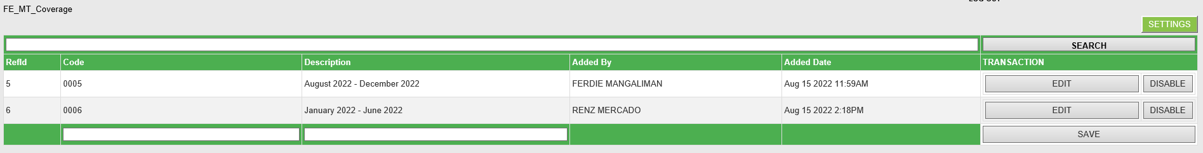

* 1. In the right side you will see SETTINGS button, this setting allows you to show/hide fields available in the list then hit SAVE CHANGES button to set your personal settings.



* 1. To add new coverage, enter code and description in the textboxes below click the save button highlighted in red.

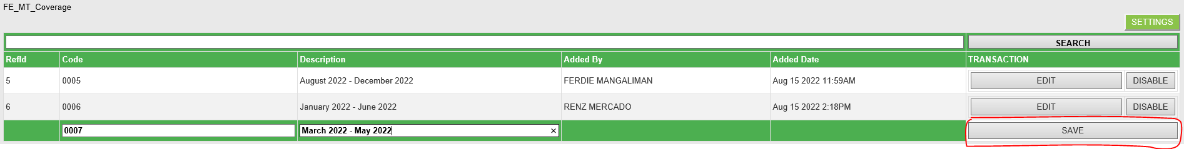

* 1. Confirmation will pop up after successfully saved.

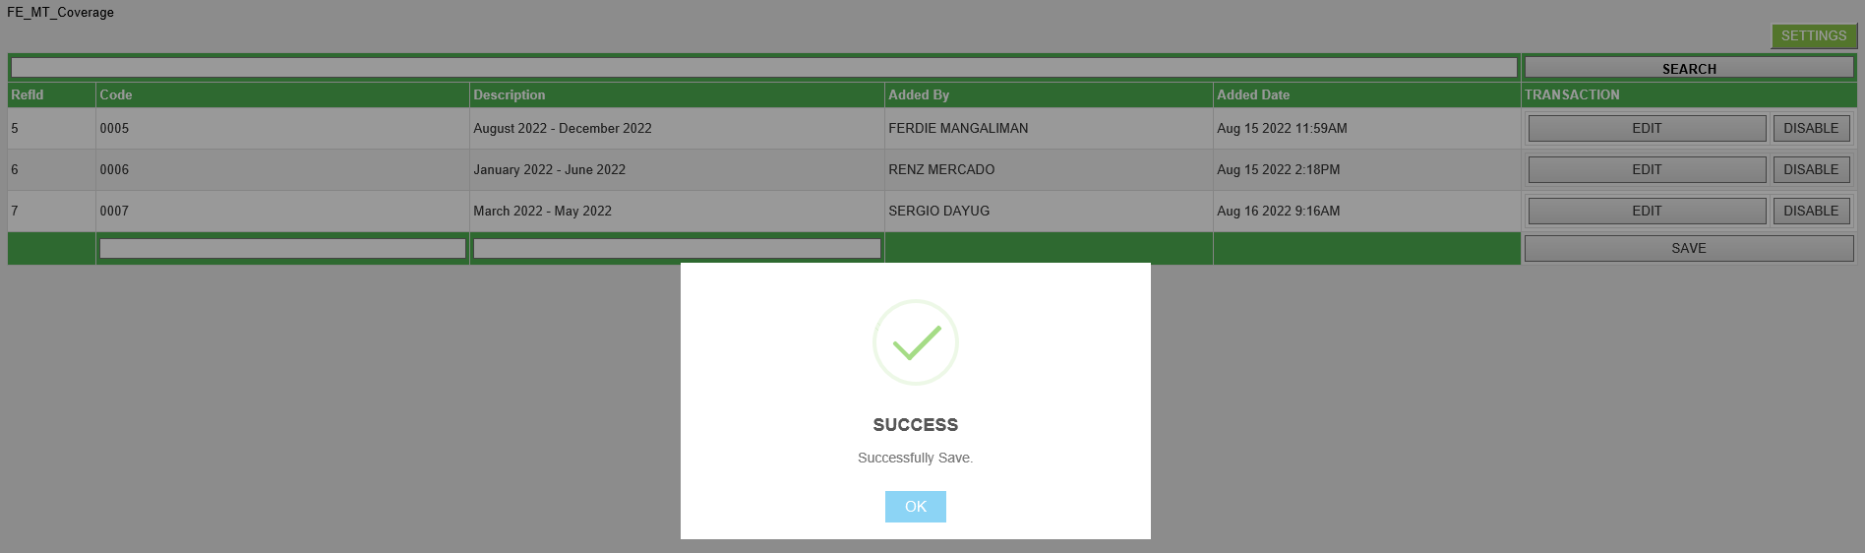

* 1. To edit the record, just click the edit button in the right side and the data will be ready for updates and click the save button in line with it to save changes. Popup confirmation with display.
  2. To disable record, just click the disable button in the right side and the data will automatically disable after hitting the button. Popup confirmation with display.

1. **How to use Cases Table**
   1. Go to TERMINAL > Forwarders Evaluation > Cases Table

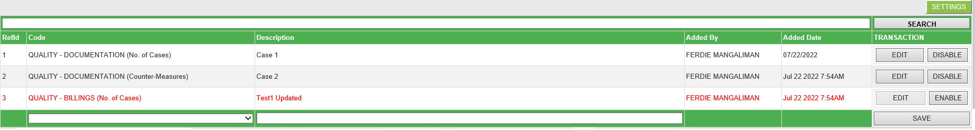

* 1. In the right side you will see SETTINGS button, this setting allows you to show/hide fields available in the list then hit SAVE CHANGES button to set your personal settings.



* 1. To add new cases, select available code in the dropdown list and enter description in the textbox below click the save button highlighted in red.

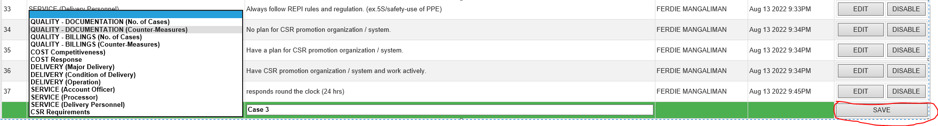

* 1. Confirmation will pop up after successfully saved.

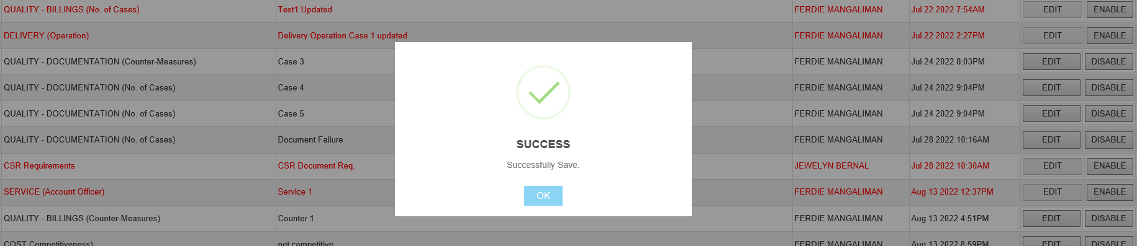

* 1. To edit the record, just click the edit button in the right side and the data will be ready for updates and click the save button in line with it to save changes. Popup confirmation with display.
  2. To disable record, just click the disable button in the right side and the data will automatically disable after hitting the button. Popup confirmation with display.

1. **How to use Buyer Scheduler Entry**
   1. Go to TERMINAL > Forwarders Evaluation > Buyer Scheduler Entry

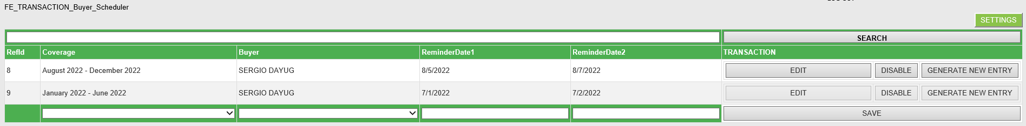

* 1. In the right side you will see SETTINGS button, this setting allows you to show/hide fields available in the list then hit SAVE CHANGES button to set your personal settings.



* 1. To add new Buyer Schedule, select available coverage and buyer in the dropdown list and enter reminder date1 and reminder date2 in the textboxes below click the save button highlighted in red.

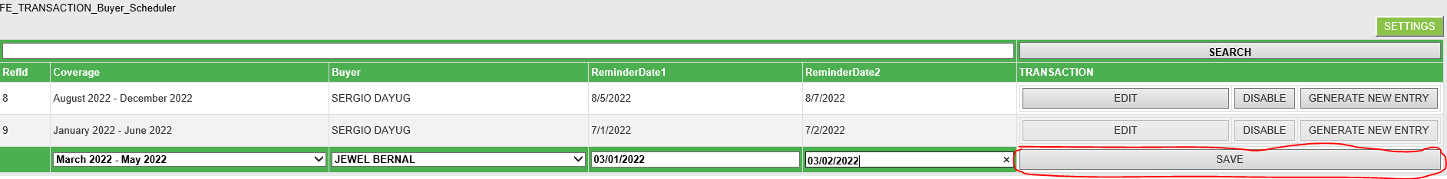

* 1. Confirmation will pop up after successfully saved.

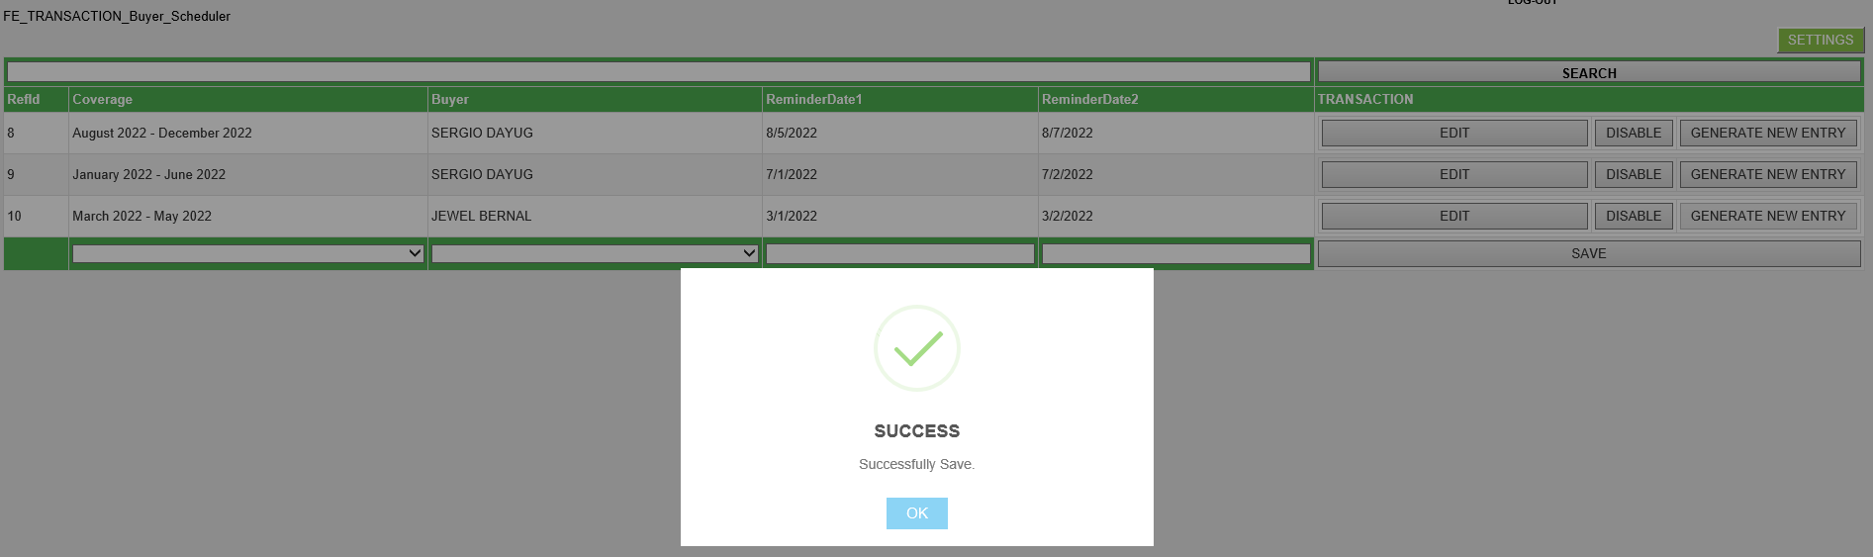

* 1. To edit the record, just click the edit button in the right side and the data will be ready for updates and click the save button in line with it to save changes. Popup confirmation with display.
  2. To disable record, just click the disable button in the right side and the data will automatically disable after hitting the button. Popup confirmation with display.
  3. What is **GENERATE NEW ENTRY** button? This button is use to create new request entry for all qualified forwarders available in Forwarders Table. By default, this button is disabled if the assigned Buyer is not the current user or not the currently sign-in user. This will only available for the assigned buyer. Please see below for sample scenario.

Record is created by Sergio Dayug

Coverage: March 2022 – May2022

Buyer: Jewel Bernal

The GENERATE NEW ENTRY button will be enabled only for Ms. Jewel Bernal since she is the In charge for March 2022 – May2022 coverage date.

* 1. Once the In charge click the GENERATE NEW ENTRY BUTTON it will display pop up reminder before submission.

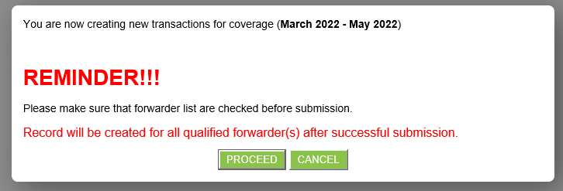

*** Please make sure that all forwarders are listed in the forwarders table before clicking the PROCEED button.

* 1. After submission, it will redirect to success page with corresponding message on how to add/create new cases entry for all forwarders.



Coverage: **March 2022 - May 2022** has been successfully created. To create new cases go to TERMINAL >> FORWARDERS EVALUATION >> TRANSACTION CASES ENTRY

1. How to use Transaction Cases Entry
   1. Go to TERMINAL > Forwarders Evaluation > Transaction Cases Entry



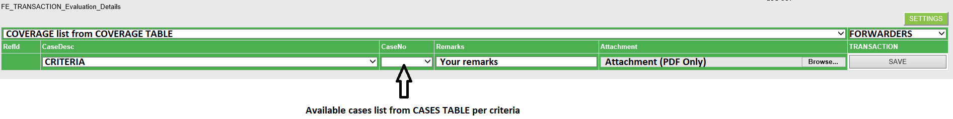

* 1. Select COVERAGE to populate available forwarders.



* 1. Select FORWARDERS to populate CRITERIA.

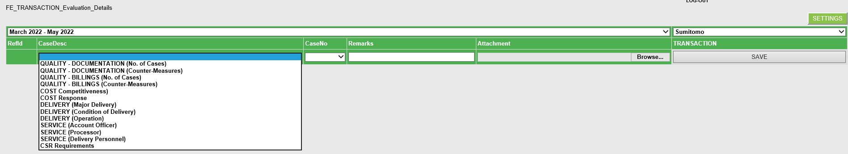

* 1. Select CRITERIA to populate CaseNo.



* 1. Enter your remarks and select your attachment if there is any then hit SAVE button. SUCCESS pop up message will appear if your entry is successfully submitted.
  2. After your first entry you will the details of your submission based on criteria and cases per forwarders.

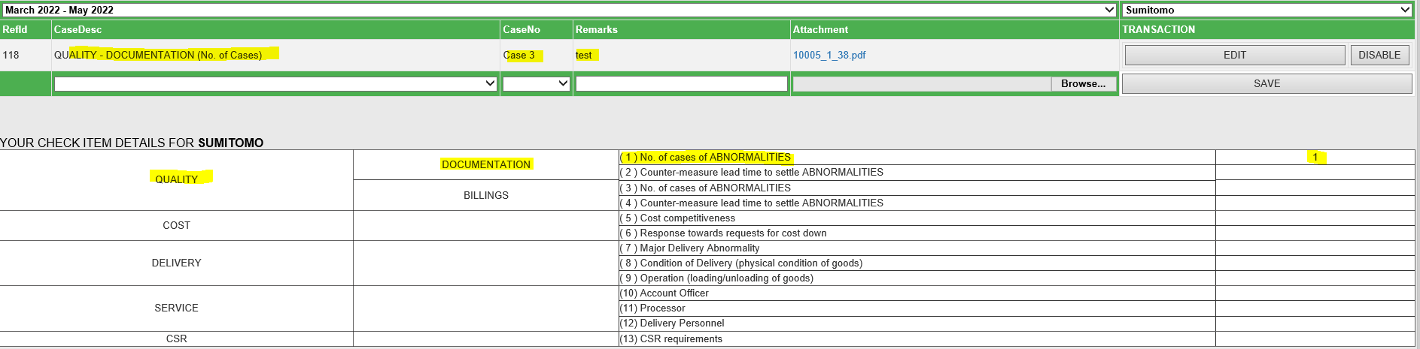

* 1. You will also be able to see other evaluators (buyers) that has entry cases for specific forwarder.

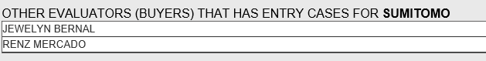

* 1. Actual evaluation check sheet for specific forwarder based on the criteria and entry cases from all evaluators (buyers) is also displayed.

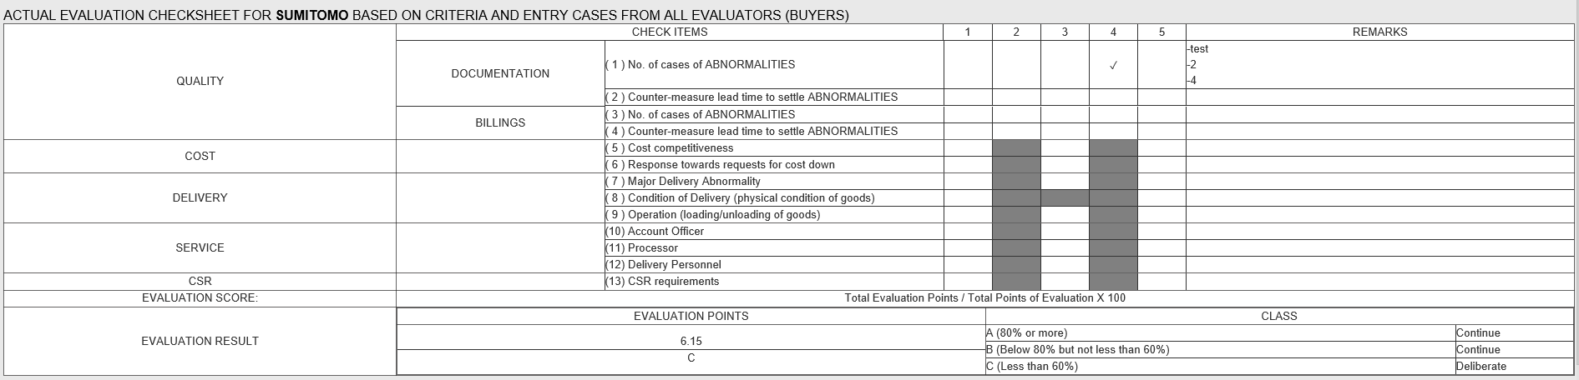

* 1. Once all buyers are completed their entries, Incharge will submit it for scheduling to forwarders. Please take note that only the Incharge will able to do the submission for scheduling for all entries.

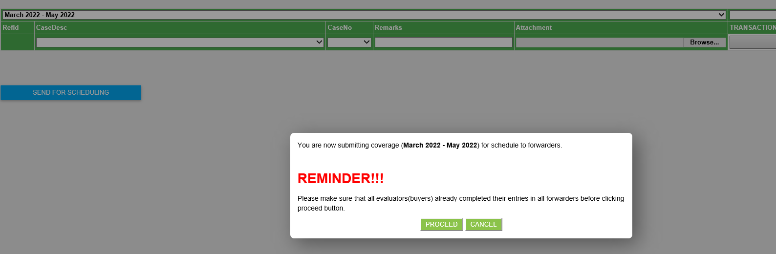

*** Please read carefully the Reminder before clicking PROCEED button. Please make sure that all evaluators (buyers) already completed their entries in all forwarders before clicking proceed button.

* 1. It will redirect to success page once the submission is successful

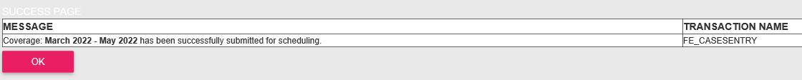

* 1. If you hit the pink OK button the it will redirect to Schedule Entry

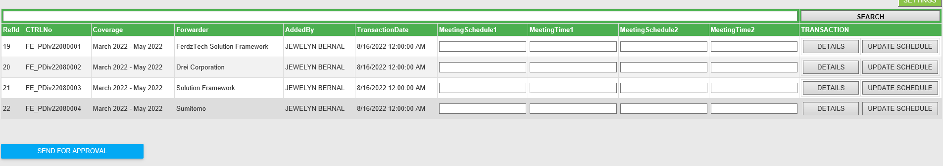

1. **How to use Transaction Schedule**
   1. Go to TERMINAL > Forwarders Evaluation > Transaction Schedule



* 1. Enter MeetingSchedule1, MeetingTime1, MeetingSchedule2, MeetingTime2 of forwarder you want to set for an schedule and click the UPDATE SCHEDULE. After clicking update schedule button, the success pop up message will appear.

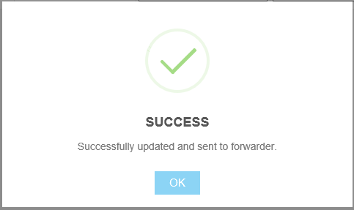

*** Please note that we have 2 kinds of success pop up message.

1. Successfully updated and sent to forwarder.
2. Successfully updated but failed to send to forwader.

The second message means that it was successfully save to our database but not able to send the email because of some reasons. (eg., Intermittent connections, LAN connection problem and etc.)

* 1. Forwarder will received an schedule email for meeting withheld.



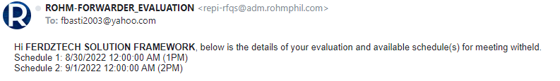

*** Instructions is also included on how the forwarder will response to the email schedule.

* 1. You will be able to see in the Schedule Entry which schedule are selected based on their response.

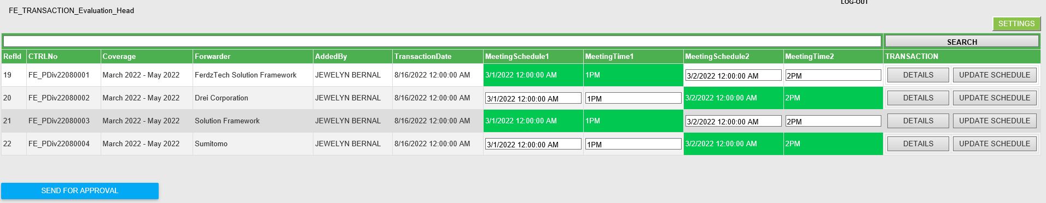

* 1. Incharge will now set the meeting withheld for all forwarders and discuss their evaluation result based on the consolidated entries from all buyers. Once done, the Incharge will send for approvals.

*** Please note that you need to make sure that meeting withheld to all forwarders are completed before sending it for approval.

*** Please note that only the Incharge has the access right to send entries for approvals. If the current user is a buyer but not the Incharge (The one that is listed in the Buyer Schedule Entry) then the SEND FOR APPROVAL button will not be displayed or not accessible. Again only the Incharge has the right access to send it for approval.

* 1. After clicking the SEND FOR APPROVAL button then it will pop up a message that you are now sending the current coverage for approval. Please make sure that meeting withheld with all forwarders are completed before clicking PROCEED button.

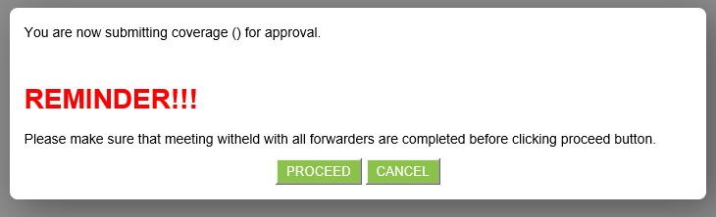

* 1. It will redirect to success page after successfully submitted.

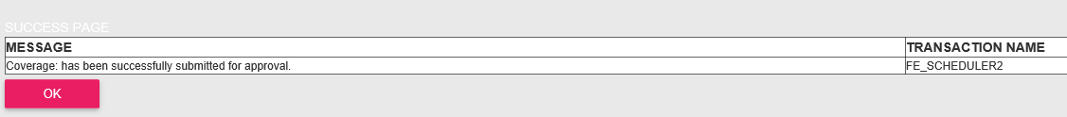

1. How to use the Transaction Approval
   1. Go to TERMINAL > Forwarders Evaluation > Buyer Transaction Approval

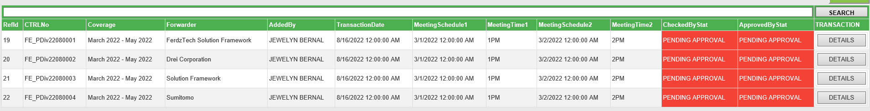

* 1. Approver will go to check the details before approving item. In this case first approver or (CHECKED) will approve the item

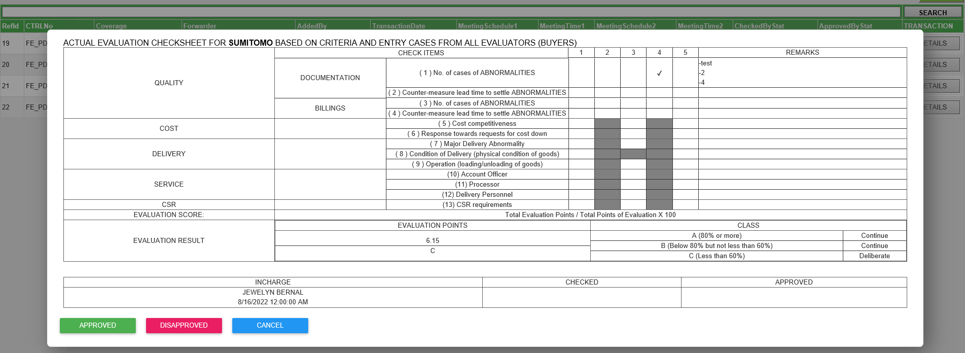

* 1. After clicking APPROVED button then it will redirect to success page. Then after clicking the pink OK button it will redirect back to the Transaction Approval.



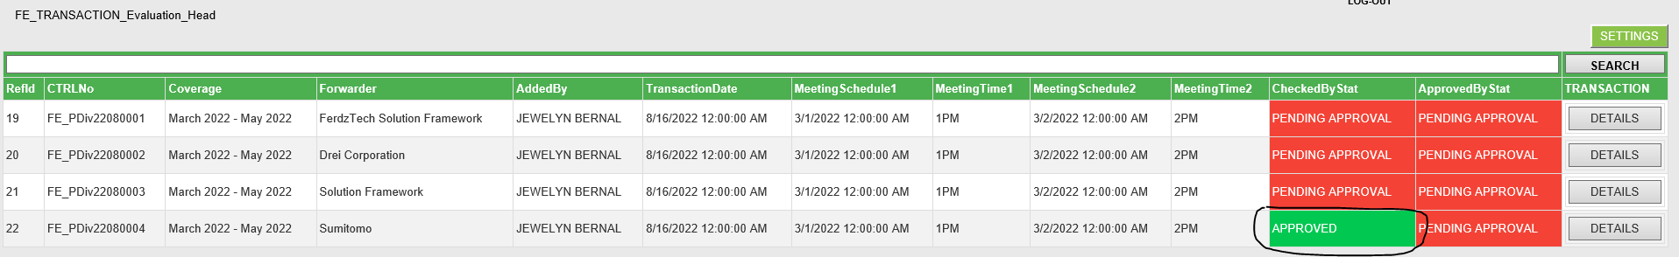

* 1. Next the (APPROVED) field will now approve the item. After this approval the result will automatically send to forwarder for ACKNOWLEDGEMENT.



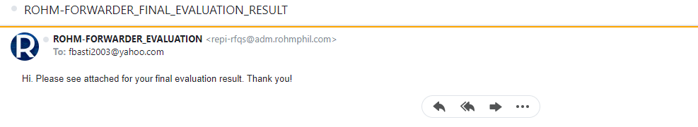

* 1. Forwarder will response accordingly to acknowledge the evaluation result.
  2. Once the our service received the response then that [Coverage-Forwarder] will marked completed or posted.